{agency logo}

{Insert Date}

{Cloud System Owner Name}
{Insert Cloud Service Name} Cloud System Owner
{Insert Address}

To: {CSP System Owner Name}

The {Federal Agency/Office} has completed the review of the {Insert CSP and cloud service name} Cloud system’s security authorization package that meets the Federal Risk and Authorization Management Program (FedRAMP) requirements. Based on the Federal Information Processing Standard (FIPS) security categorization of “{Low, Moderate, or High}” and the provided Security Assessment, the {Federal Agency/Office} has determined that the {Insert CSP and cloud service name} Cloud system meets the information security requirements and is granted an Authority to Operate.

The security authorization of the information system will remain in effect for a length of time in alignment with Office of Management and Budget Circular A-130 as long as:
- {Insert CSP name} satisfies the requirement of implementing continuous monitoring activities as documented in FedRAMP’s continuous monitoring requirements and {Insert CSP name} Continuous Monitoring Plan;
- {Insert CSP name} mitigates all open POA&M action items, agreed to in the Security Assessment Report (SAR) and as developed during the continuous monitoring activities; and
- Significant changes or critical vulnerabilities are identified and managed in accordance with applicable Federal law, guidelines, and policies.

{Federal Agency/Office} is leveraging the documentation provided within the FedRAMP secure repository as a key element of the Authority to Operate (ATO). Based on the documentation within the FedRAMP secure repository and customer-specific tailoring and operating procedures, the {Federal Agency/Office} believes the security authorization package accurately documents the {Insert CSP name} cloud system and clearly defines outstanding risk considerations.

SIGNED:

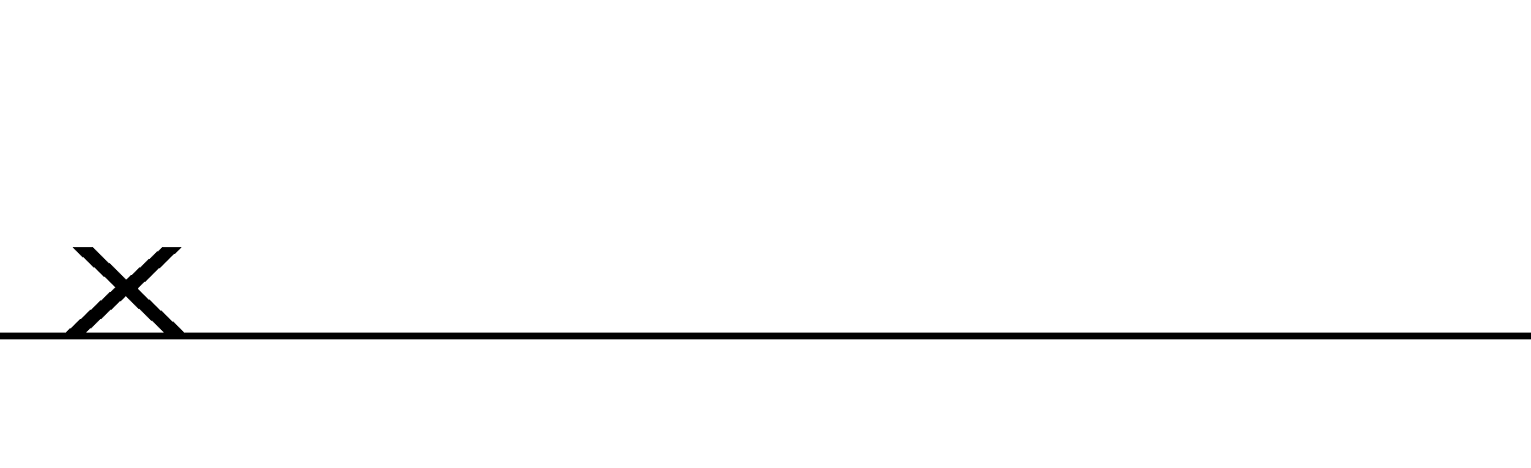
{Authorizing Official}
{Title}
{Office}
{Agency}
{Street Address}
{City, State, Zip}
{Phone}
{Email}

cc FedRAMP PMO at info@FedRAMP.gov

